SAFETY DATA SHEET
OSHA HCS (29 CFR 1910.1200)

SECTION 1: PRODUCT AND COMPANY IDENTIFICATION
Product identifier
 | Chemical Name | Mixture
 | CAS No. | Mixture
 | Trade Name | LT5 Leather Protector Consumer
 | Product Code | None
Relevant identified uses of the substance or mixture and uses advised against
 | Identified Use(s) | Leather Care / Consumer Product
 | Uses Advised Against | None
 | Company Identification | Spray Products Corporation  P.O. Box 737  Norristown, PA 19404
 | Telephone | (610) 277-1010
 | Fax | (610) 277-4390
 | E-Mail (competent person) | sds@sprayproducts.com
Emergency telephone number
 | Emergency Phone No. | Transportation Emergency: CHEMTREC 24 hr. 1-800-424-9300 / 1 (703) 527-3887 (Collect calls accepted)

SECTION 2: HAZARDS IDENTIFICATION
Classification of the substance or mixture
 | OSHA HCS (29 CFR 1910.1200) | Flam. Aerosol 2; Liquefied gas; Skin Irrit. 2; Asp. Tox. 1; STOT SE 3
Label elements
 | Hazard Symbol | 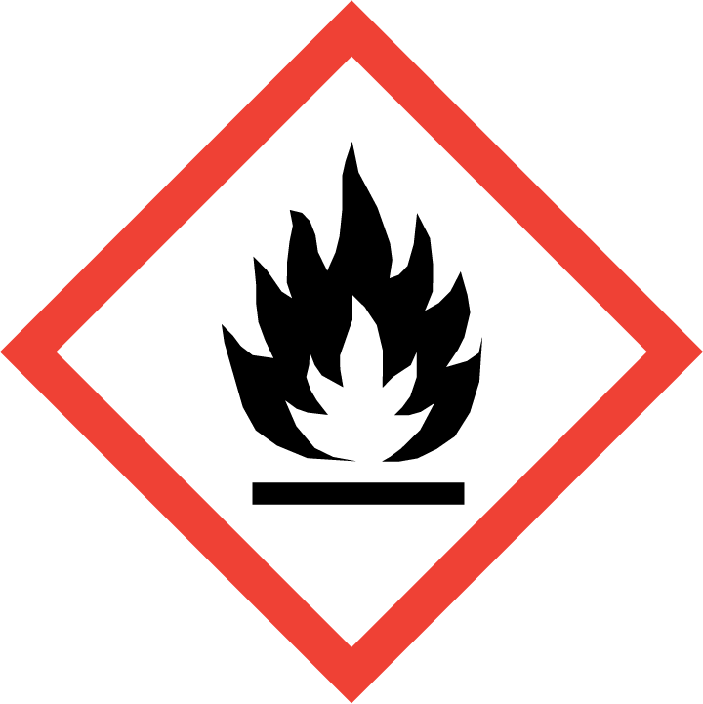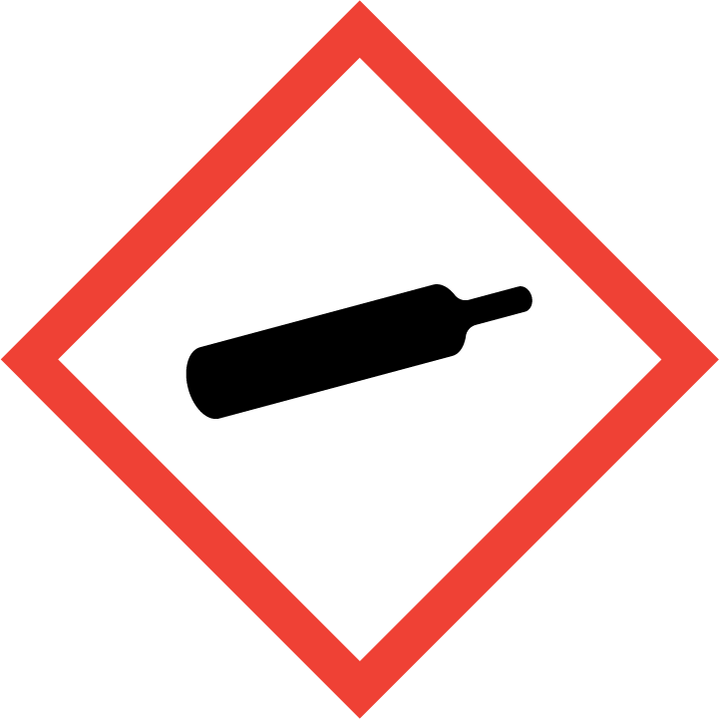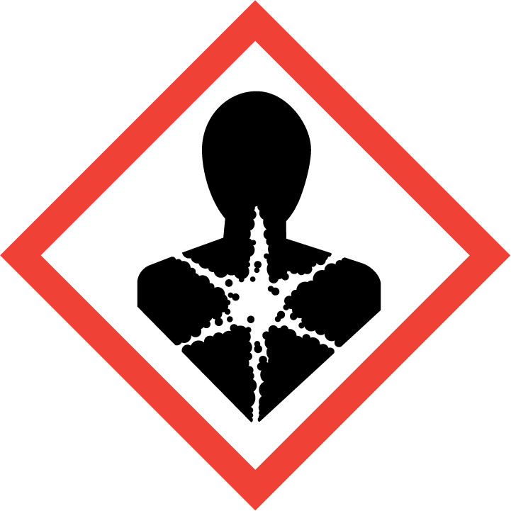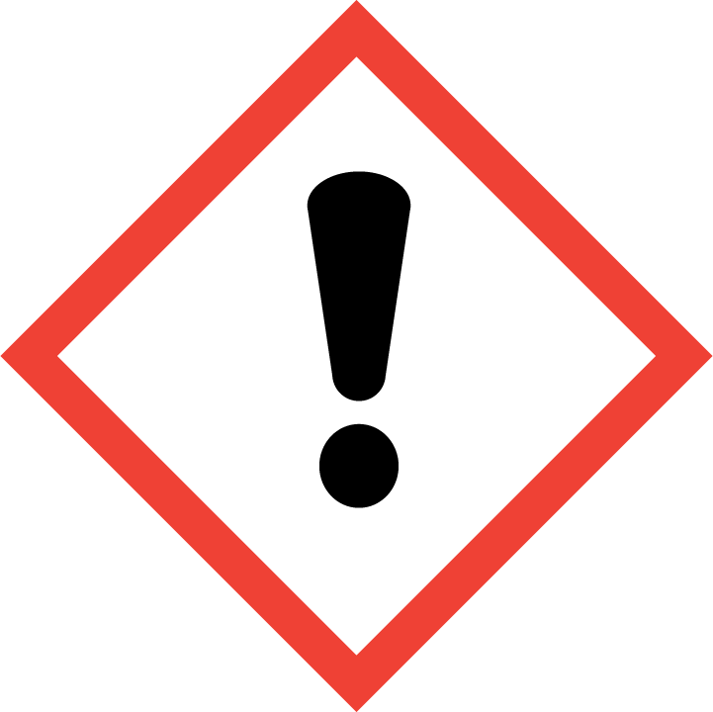
 | Signal word(s) | DANGER
 | Hazard Statement(s) | Flammable aerosol.  Contains gas under pressure; may explode if heated.  Causes skin irritation.  May be fatal if swallowed and enters airways.  May cause drowsiness or dizziness.
 | Precautionary Statement(s) | Keep away from heat, hot surfaces, sparks, open flames and other ignition sources. No smoking.  Do not spray on an open flame or other ignition source.  Do not pierce or burn, even after use.  Wash hands and exposed skin after use.  Wear protective gloves/protective clothing/eye protection/face protection.  Avoid breathing dust/fume/gas/mist/vapours/spray.  Protect from sunlight and do not expose to temperatures exceeding 50 ºC/122 ºF.
Other hazards |  | Toxic to aquatic life. Toxic to aquatic life with long lasting effects.

SECTION 3: COMPOSITION/INFORMATION ON INGREDIENTS
Hazardous Ingredient(s) | % wt. | CAS No. | Hazard classification
Distillates (petroleum), hydrotreated light | 5 - 15 | 64742-47-8 | Flam. Liq. 4; H227  Skin Irrit. 2; H315  Asp. Tox. 1; H304  STOT SE 3; H336  Aquatic Acute 2; H401  Aquatic Chronic 2; H411
Propane | 5 - 6 | 74-98-6 | Flam. Gas 1; H220  Liquefied gas; H280
n-Butane | 4 - 5 | 106-97-8 | Flam. Gas 1, H220  Press. Gas (*)
Ammonia, aqueous solution | 0.8 | 1336-21-6 | Skin Irrit. 2; H315  Eye Irrit. 2; H319
Water | 65 - 70 | 7732-18-5 | Not classified as dangerous for supply/use.
Polydimethyl siloxane | 1 - 10 | 63148-62-9 | Not classified as dangerous for supply/use.
[2-(2 methoxymethylethoxy)methylethoxy]propanol | 3 - 5 | 25498-49-1 | Not classified as dangerous for supply/use.
Sorbitan monooleate | 0.1 - 1 | 1338-43-8 | Not classified as dangerous for supply/use.

Additional Information - None
* The exact percentage withheld as a trade secret in accordance with 29 CFR 1910.1200.

SECTION 4: FIRST AID MEASURES

Description of first aid measures
 | Inhalation |  | Move person to fresh air. If breathing is laboured, administer oxygen. If symptoms develop, obtain medical attention.
 | Skin Contact |  | Wash affected skin with soap and water. If symptoms develop, obtain medical attention.
 | Eye Contact |  | Rinse cautiously with water for several minutes. Remove contact lenses, if present and easy to do. Continue rinsing. If eye irritation persists, get medical advice/attention.
 | Ingestion |  | Immediately call a POISON CENTER or doctor/physician. Do not induce vomiting. Do not give anything by mouth to an unconscious person.
Most important symptoms and effects, both acute and delayed |  |  | Aspiration of droplets may cause pulmonary oedema.
Indication of any immediate medical attention and special treatment needed |  |  | IF SWALLOWED: Immediately call a POISON CENTER or doctor/physician. Do NOT induce vomiting.

SECTION 5: FIRE-FIGHTING MEASURES
Extinguishing Media
-Suitable Extinguishing Media |  | Extinguish with carbon dioxide, dry chemical, foam or waterspray.
-Unsuitable Extinguishing Media |  | Do not use water jet.
Special hazards arising from the substance or mixture |  | Pressurised container: May burst if heated
Advice for fire-fighters |  | A self contained breathing apparatus and suitable protective clothing should be worn in fire conditions. Keep containers cool by spraying with water if exposed to fire.

SECTION 6: ACCIDENTAL RELEASE MEASURES
Personal precautions, protective equipment and emergency procedures | Keep away from heat/sparks/open flames/hot surfaces. – No smoking. Avoid contact with skin and eyes. Avoid breathing gas/spray.
Environmental precautions | Prevent liquid entering sewers, basements and work pits.
Methods and material for containment and cleaning up | Cover spills with inert absorbent material. Transfer to a container for disposal or recovery.
Reference to other sections | None
Additional Information | None

SECTION 7: HANDLING AND STORAGE
Precautions for safe handling | Keep away from heat, hot surfaces, sparks, open flames and other ignition sources. No smoking. Avoid contact with skin and eyes. Use product in a well-ventilated area only. Avoid breathing gas/spray.
Conditions for safe storage, including any incompatibilities
-Storage temperature | Store in a well-ventilated place. Protect from sunlight. Store at temperatures not exceeding 50 °C / 122 °F.
-Incompatible materials | This product should be stored away from sources of strong heat or oxidizing chemicals.
Specific end use(s) | Leather Care / Consumer Product

SECTION 8: EXPOSURE CONTROLS/PERSONAL PROTECTION
Occupational Exposure Limits
SUBSTANCE. | CAS No. | (8hr TWA) |  | (STEL) |  | Note:
SUBSTANCE. | CAS No. | PEL  (OSHA) | TLV (ACGIH) | PEL  (OSHA) | TLV (ACGIH) | Note:
C₉-C₁₅ Alkanes & Cycloalkanes | Mixture | ----- | 1200 mg/m³ | ----- | -----
n-Butane | 106-97-8 | ----- | 250 ppm | ----- | ----- | -----
Propane | 74-98-6 | 1000 ppm | Aspyx.# | ----- | ----- | #
#Assure minimum oxygen content of work atmosphere.
Recommended monitoring method |  | NIOSH 1500 (hydrocarbons, B.P. 36 - 216 ºC); NIOSH 1550 (Naphthas)
Exposure controls
Appropriate engineering controls |  |  |  | Provide adequate ventilation to ensure that the occupational exposure limit is not exceeded.
Personal protection equipment
 | Eye/face protection   |  |  | Wear protective eyewear (goggles, face shield, or safety glasses).
 | Skin protection (Hand protection/ Other)   |  |  | Wear suitable gloves if prolonged skin contact is likely (Nitrile rubber or Butyl rubber). Check with protective equipment manufacturer's data.
 | Respiratory protection   |  |  | Normally no personal respiratory protection is necessary. In case of insufficient ventilation, wear suitable respiratory equipment. Check with protective equipment manufacturer's data.
 | Thermal hazards |  |  | Not normally required. Use gloves with insulation for thermal protection, when needed.
Environmental Exposure Controls |  |  |  | None known

SECTION 9: PHYSICAL AND CHEMICAL PROPERTIES
Information on basic physical and chemical properties
Appearance | Aerosol spray
Color. | Clear
Odor | Fuel oil-like
Odor Threshold (ppm) | Not available
pH (Value) | Not available
Melting Point (°C) / Freezing Point (°C) | Not available
Boiling point/boiling range (°C): | Not available
Flash Point (°C) | -104 (Propane)
Evaporation Rate | Not available
Flammability (solid, gas) | Flammable aerosol
Explosive Limit Ranges | 2.1% - 9.5% v/v (Propane)
Vapor pressure (Pascal) | ca. 95 x 10⁴ (Propane)
Vapor Density (Air=1) | ca. 1.56 @ 0 ºC (Propane)
Density (g/ml) | Not available.
Solubility (Water) | Not available
Solubility (Other) | Not available
Partition Coefficient (n-Octanol/water) | Not available
Auto Ignition Point (°C) | Not available
Decomposition Temperature (°C) | Not available
Kinematic Viscosity (cSt) | < 20.5 @ 40 0ºC
Explosive properties | Not explosive.
Oxidizing properties | Not oxidizing.
Other information | Not available

SECTION 10: STABILITY AND REACTIVITY
Reactivity | Stable under normal conditions.
Chemical stability | Stable.
Possibility of hazardous reactions | None anticipated.
Conditions to avoid | Avoid contact with heat and ignition sources.
Incompatible materials | This product should be stored away from sources of strong heat or oxidizing chemicals.
Hazardous decomposition product(s) | Carbon monoxide, Carbon dioxide, Acrid smoke, Other

SECTION 11: TOXICOLOGICAL INFORMATION
Exposure routes: Inhalation, Skin Contact, Eye Contact
Information on toxicological effects
Hydrotreated Light Distillate (CAS No. 64742-47-8) - By analogy with similar materials:
Acute toxicity (calculated / estimated) | Oral: LD50 >5000 mg/kg-bw  Dermal: LD50 >2000 mg/kg-bw  Inhalation: LC0 ≥5.28 mg/l (Vapor), 4-hr. rat - May cause drowsiness or dizziness.
Irritation/Corrosivity | Causes skin irritation. Repeated exposure may cause skin dryness or cracking.
Sensitization | It is not a skin sensitizer.
Repeated dose toxicity | Oral: NOEAL 750 mg/kg  Dermal: NOEAL 0.5 ml/kg bw  Inhalation: NOAEL ≥1000 mg/m3
Carcinogenicity | It is unlikely to present a carcinogenic hazard to man.
NTP | IARC | ACGIH | OSHA | NIOSH
No. | No. | No. | No. | No.

Mutagenicity | Not to be expected
Reproductive toxicity | Not to be expected
Propane (CAS# 74-98-6):
Acute toxicity |  | Inhalation: LC50 = 1237 mg/L (2-hr, mouse, gas)
Irritation/Corrosivity |  | No evidence of irritant effects from normal handling and use.
Sensitisation |  | It is not a skin sensitiser.
Repeated dose toxicity |  | NOAEC: >19678 mg/m3 (28-day, rat, Systemic effects)  LOAEC: 21641 mg/m3 (28-day, rat, effects: Body weight)
Carcinogenicity |  | No data. It is unlikely to present a carcinogenic hazard to man.
Mutagenicity |  | There is no evidence of mutagenic potential.
Reproductive toxicity |  | None anticipated

SECTION 12: ECOLOGICAL INFORMATION

Ecotoxicity
Hydrotreated Light Distillate (CAS No. 64742-47-8) - By analogy with similar materials:
Short term | LC50 (96 hour): 2.5 mg/L (fish)  EC50 (48 hour): 1.4 mg/L (crustacea)  EC50 (72 hour): 1.3 mg/L (algae)
Long Term | NOEC (28 days): 0.098 mg/L (fish)  LOEC (21 days): 1.2 mg/L (crustacea)  LOEL (72 hour): 1 mg/L (algae)

SECTION 13: DISPOSAL CONSIDERATIONS
Waste treatment methods | Disposal should be in accordance with local, state or national legislation. Consult an accredited waste disposal contractor or the local authority for advice.

SECTION 14: TRANSPORT INFORMATION
 | U.S. DOT | Sea transport  (IMDG) | Air transport (ICAO/IATA)
UN number | 1950 | 1950 | 1950
Proper Shipping Name | Aerosols, flammable | Aerosols, flammable | Aerosols, flammable
Transport hazard class(es) | 2.1 | 2.1 | 2.1
Packing group | Not applicable | Not applicable | Not applicable
Environmental hazards | None assigned | None assigned | None assigned
Special precautions for user | None assigned | None assigned | None assigned
Transport in bulk according to Annex II of MARPOL73/78 and the IBC Code: Not applicable

SECTION 15: REGULATORY INFORMATION
Safety, health and environmental regulations/legislation specific for the substance or mixture:
TSCA (Toxic Substance Control Act) - Inventory Status: All components listed or polymer exempt.
Designated Hazardous Substances and Reportable Quantities (40 CFR 302.4):
 |  | Chemical Name | CAS No. |  |  | Typical %wt. |  |  |  | RQ (Pounds)
 |  | None | ---- |  |  | ---- |  |  |  | ----
SARA 311/312 - Hazard Categories: See SECTION 2: HAZARDS IDENTIFICATION
SARA 313 - Toxic Chemicals (40 CFR 372):
 |  | Chemical Name |  |  |  |  | CAS No. |  |  |  |  | Typical %wt.
 |  | None |  |  |  |  | ---- |  |  |  |  | ----
SARA 302 - Extremely Hazardous Substances(40 CFR 355):
 |  | Chemical Name |  |  | CAS No. |  |  |  | Typical %wt. |  | TPQ (pounds)
 |  | None |  |  | ---- |  |  |  | ---- |  | ----
California Proposition 65 List:
 |  | Chemical Name |  | CAS No. |  |  |  | Type of Toxicity
 |  | None |  | ---- |  |  |  | ----

SECTION 16: OTHER INFORMATION
The following sections contain revisions or new statements: 1-16.
Date of preparation: March 22, 2016
Hazard Statement(s) and Risk Phrases Listed in: SECTION 2:/ SECTION 3:
Hazard Statement(s)
- H220: Extremely flammable gas.
- H227: Combustible liquid.
- H280: Contains gas under pressure; may explode if heated.
- H304: May be fatal if swallowed and enters airways.
- H315: Causes skin irritation.
- H336: May cause drowsiness or dizziness.
- H401: Toxic to aquatic life.
- H411: Toxic to aquatic life with long lasting effects.
Training advice: None.
Disclaimer: We believe the statements, technical information and recommendations contained herein are reliable, but they are given without warranty or guarantee of any kind. The information contained in this document applies to this specific material as supplied. It may not be valid for this material if it is used in combination with any other materials. It is the user’s responsibility to satisfy oneself as to the suitability and completeness of this information for the user’s own particular use.

