SAFETY DATA SHEET
OSHA HCS (29 CFR 1910.1200)

SECTION 1: PRODUCT AND COMPANY IDENTIFICATION
Product identifier
 | Chemical Name | Mixture
 | CAS No. | Mixture
 | Trade Name | FW1 AirSea Wash and Wax
 | Product Code | N/A
Relevant identified uses of the substance or mixture and uses advised against
 | Identified Use(s) | Automotive Care Product
 | Uses Advised Against | None
 | Company Identification | Spray Products Corporation  P.O. Box 737  Norristown, PA 19404
 | Telephone | (610) 277-1010
 | Fax | (610) 277-4390
 | E-Mail (competent person) | johnd@sprayproducts.com
Emergency telephone number
 | Emergency Phone No. | Transportation Emergency: CHEMTREC 24 hr. 1-800-424-9300 / 1 (703) 527-3887 (Collect calls accepted)

SECTION 2: HAZARDS IDENTIFICATION
Classification of the substance or mixture
 | OSHA HCS (29 CFR 1910.1200) | Flam. Aerosol 1; Liquefied gas; Skin Irrit. 2; STOT SE 3; Asp. Tox. 1
Label elements
 | Hazard Symbol | 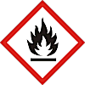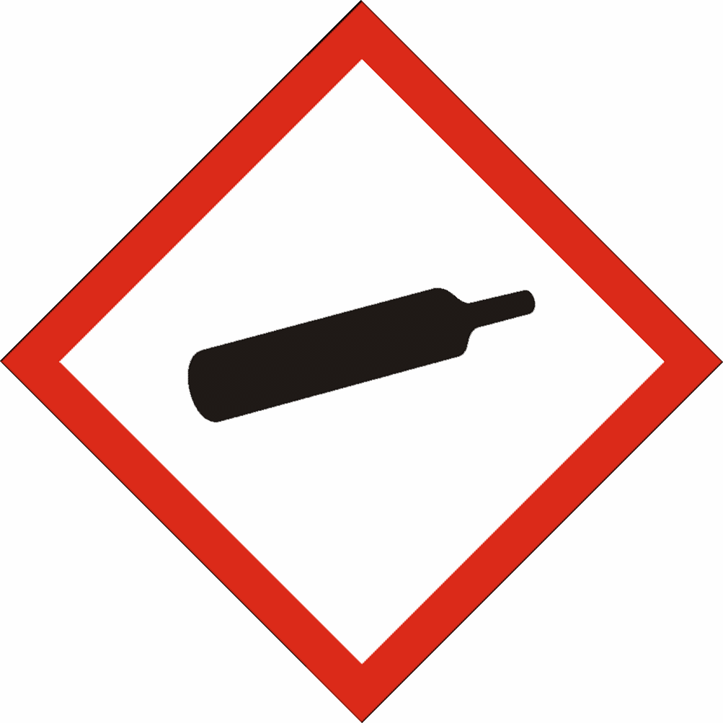
 | Signal word(s) | DANGER
 | Hazard Statement(s) | Extremely flammable aerosol.  Contains gas under pressure; may explode if heated.  Causes skin irritation.  May cause drowsiness or dizziness.  May be fatal if swallowed and enters airways.
 | Precautionary Statement(s) | Keep away from heat/sparks/open flames/hot surfaces. – No smoking.  Do not spray on an open flame or other ignition source.  Do not pierce or burn, even after use.  Protect from sunlight and do not expose to temperatures exceeding 50 ºC/122 ºF.  Wear protective gloves/protective clothing/eye protection/face protection.  Use only outdoors or in a well-ventilated area.  Avoid breathing spray.  Wash hands and exposed skin after use.  Keep out of reach of children.
Other hazards |  | Harmful to aquatic life.

SECTION 3: COMPOSITION/INFORMATION ON INGREDIENTS
Hazardous ingredient(s) | %W/W * | CAS No. | Hazard classification
Petroleum Distillates | 5 - 20 | various | Flam. Liq. 2; H225  Asp. Tox. 1; H304  Skin Irrit. 2; H315  STOT SE 3; H336  Aquatic Acute 2; H401  Aquatic Chronic 3; H412
Propane | 5 - 10 | 74-98-6 | Flam. Gas 1, H220  Press. Gas (*)

Additional Information - None
* The exact percentage withheld as a trade secret in accordance with 29 CFR 1910.1200.

SECTION 4: FIRST AID MEASURES

Description of first aid measures
 | Inhalation |  | Move person to fresh air. If breathing is laboured, administer oxygen. If symptoms develop, obtain medical attention.
 | Skin Contact |  | Wash affected skin with soap and water. If symptoms develop, obtain medical attention.
 | Eye Contact |  | Rinse cautiously with water for several minutes. Remove contact lenses, if present and easy to do. Continue rinsing. If eye irritation persists: Get medical advice/attention.
 | Ingestion |  | Do not give anything by mouth to an unconscious person. Do NOT induce vomiting.
Most important symptoms and effects, both acute and delayed |  |  | May be fatal if swallowed and enters airways. Will cause skin irritation. Vapours may cause drowsiness and dizziness.
Indication of any immediate medical attention and special treatment needed |  |  | IF SWALLOWED: Immediately call a POISON CENTER or doctor/physician. Do NOT induce vomiting.

SECTION 5: FIRE-FIGHTING MEASURES
Extinguishing Media
-Suitable Extinguishing Media |  | Extinguish with carbon dioxide, dry chemical, foam or waterspray.
-Unsuitable Extinguishing Media |  | Do not use water jet.
Special hazards arising from the substance or mixture |  | Highly flammable vapour (flash point below 23°C).
Advice for fire-fighters |  | A self contained breathing apparatus and suitable protective clothing should be worn in fire conditions. Keep containers cool by spraying with water if exposed to fire.

SECTION 6: ACCIDENTAL RELEASE MEASURES
Personal precautions, protective equipment and emergency procedures | Keep away from heat/sparks/open flames/hot surfaces. – No smoking. Avoid contact with skin and eyes. Avoid breathing gas/spray. Avoid contact with skin and eyes.
Environmental precautions | Prevent liquid entering sewers, basements and work pits.
Methods and material for containment and cleaning up | Cover spills with inert absorbent material. Transfer to a container for disposal or recovery.
Reference to other sections | None
Additional Information | None

SECTION 7: HANDLING AND STORAGE
Precautions for safe handling | Keep away from heat, hot surfaces, sparks, open flames and other ignition sources. No smoking. Avoid contact with skin and eyes. Use product in a well-ventilated area only.
Conditions for safe storage, including any incompatibilities
-Storage temperature | Keep in a cool, well ventilated place. Store at temperatures not exceeding 50°C / 122 °F.
-Incompatible materials | This product should be stored away from sources of strong heat or oxidizing chemicals.
Specific end use(s) | Automotive Care Product

SECTION 8: EXPOSURE CONTROLS/PERSONAL PROTECTION
Occupational Exposure Limits
SUBSTANCE. | CAS No. | (8hr TWA) |  | (STEL) |  | Note:
SUBSTANCE. | CAS No. | PEL  (OSHA) | TLV (ACGIH) | PEL  (OSHA) | TLV (ACGIH) | Note:
Heptane, branched, cylic and linear | 426260-76-6 | 500 ppm* | 1500 mg/m³ | ----- | ----- | *n-heptane
C₉-C₁₅ Alkanes & Cycloalkanes | Mixture | ----- | 1200 mg/m³ | ----- | -----
Propane | 74-98-6 | 1000 ppm | Aspyx.# | ----- | ----- | #
#Assure minimum oxygen content of work atmosphere.
Recommended monitoring method |  | NIOSH 1500 (hydrocarbons, B.P. 36 - 126 ºC); NIOSH 1550 (Naphthas)
Exposure controls
Appropriate engineering controls |  |  |  | Use only with adequate ventilation to keep exposures (airborne levels of dust, fume, vapour etc) below recommended exposure limits.
Personal protection equipment
 | Eye/face protection   |  |  | Wear protective eyewear (goggles, face shield, or safety glasses).
 | Skin protection (Hand protection/ Other)   |  |  | Wear suitable gloves if prolonged skin contact is likely (Nitrile rubber)
 | Respiratory protection   |  |  | Normally no personal respiratory protection is necessary. In case of insufficient ventilation, wear suitable respiratory equipment. Check with protective equipment manufacturer's data.
 | Thermal hazards |  |  | Not normally required. Use gloves with insulation for thermal protection, when needed.
Environmental Exposure Controls |  |  |  | None known

SECTION 9: PHYSICAL AND CHEMICAL PROPERTIES
Information on basic physical and chemical properties
Appearance | Liquid / Liquefied gas
Color. | Clear
Odor | Petroleum spirit
Odor Threshold (ppm) | Not available
pH (Value) | Not available
Melting Point (°C) / Freezing Point (°C) | Not available
Boiling point/boiling range (°C): | Not available
Flash Point (°C) | -104 (Propane)
Evaporation Rate | Not available
Flammability (solid, gas) | Extremely flammable
Explosive Limit Ranges | 2.1% - 9.5% v/v (Propane)
Vapor pressure (Pascal) | ca. 95 x 10⁴ (Propane)
Vapor Density (Air=1) | ca. 1.56 @ 0ºC (Propane)
Density (g/ml) | Not available
Solubility (Water) | Not available
Solubility (Other) | Not available
Partition Coefficient (n-Octanol/water) | Not available
Auto Ignition Point (°C) | 450 (Propane)
Decomposition Temperature (°C) | Not available
Kinematic Viscosity (cSt) | <20
Explosive properties | Not explosive.
Oxidizing properties | Not oxidising.
Other information | Not available

SECTION 10: STABILITY AND REACTIVITY
Reactivity | Stable under normal conditions.
Chemical stability | Stable.
Possibility of hazardous reactions | None anticipated.
Conditions to avoid | Avoid contact with heat and ignition sources.
Incompatible materials | This product should be stored away from sources of strong heat or oxidizing chemicals.
Hazardous decomposition product(s) | None known

SECTION 11: TOXICOLOGICAL INFORMATION
Exposure routes: Inhalation, Skin Contact, Eye Contact
Heptane, branched, cylic and linear (CAS# 426260-76-6) - By analogy with similar materials:
Acute toxicity |  | Oral: LD50 >5 g/kg-bw  Dermal: LD50 >2 g/kg-bw  Inhalation: LC50 = 65 - 103 mg/L (Vapour), 4-hr. rat  May cause drowsiness or dizziness.
Irritation/Corrosivity |  | Causes skin irritation. Repeated exposure may cause skin dryness or cracking. May cause eye irritation.
Sensitisation |  | It is not a skin sensitiser.
Repeated dose toxicity |  | NOAEC: 12350 mg/m3 (2 yr, inhal., rat, Systemic effects)  LOAEC: 1650 mg/m3 (2 hr, inhal., rat, CNS effects)  May cause drowsiness or dizziness.
Carcinogenicity |  | No data. It is unlikely to present a carcinogenic hazard to man.
Mutagenicity |  | There is no evidence of mutagenic potential.
Reproductive toxicity |  | None anticipated
 | Propane (CAS# 74-98-6):
 | Acute toxicity | Inhalation: LC50 = 1237 mg/L (2-hr, mouse, gas)
 | Irritation/Corrosivity | No evidence of irritant effects from normal handling and use.
 | Sensitisation | It is not a skin sensitiser.
 | Repeated dose toxicity | NOAEC: >19678 mg/m3 (28-day, rat, Systemic effects)  LOAEC: 21641 mg/m3 (28-day, rat, effects: Body weight)
 | Carcinogenicity | No data. It is unlikely to present a carcinogenic hazard to man.
 | Mutagenicity | There is no evidence of mutagenic potential.
 | Reproductive toxicity | None anticipated

SECTION 12: ECOLOGICAL INFORMATION

Aquatic toxicity:
Heptane, branched, cylic and linear (CAS# 426260-76-6) - By analogy with similar materials:
Short term | LL50 (96 hour): >13.4 mg/L (Oncorhynchus mykiss)  EL50 (48 hour): 3 mg/l (Daphnia magna, mobility)  EC50 (96 hour): 13 mg/l (Pseudokirchnerella subcapitata)
Long Term | NOELR (28 days) 1.5 mg/l (Fish) QSAR  LOEC (21 days): 0.32 mg/l (Daphnia magna)  NOEL (96 hour) 6.3 mg/l (Algae)

SECTION 13: DISPOSAL CONSIDERATIONS
Waste treatment methods | Disposal should be in accordance with local, state or national legislation. Consult an accredited waste disposal contractor or the local authority for advice.

SECTION 14: TRANSPORT INFORMATION
 | U.S. DOT | Sea transport  (IMDG) | Air transport (ICAO/IATA)
UN number | 1950 | 1950 | 1950
Proper Shipping Name | Aerosols, flammable | Aerosols, flammable | Aerosols, flammable
Transport hazard class(es) | 2.1 | 2.1 | 2.1
Packing group | Not applicable | Not applicable | Not applicable
Environmental hazards | None assigned | None assigned | None assigned
Special precautions for user | None assigned | None assigned | None assigned
Transport in bulk according to Annex II of MARPOL73/78 and the IBC Code: Not applicable

SECTION 15: REGULATORY INFORMATION
Safety, health and environmental regulations/legislation specific for the substance or mixture:
TSCA (Toxic Substance Control Act) - Inventory Status: All components listed or polymer exempt.
Designated Hazardous Substances and Reportable Quantities (40 CFR 302.4):
 |  |  | Chemical Name | CAS No. |  |  | Typical %wt. |  |  |  | RQ (Pounds)
 |  |  | Sodium Nitrite | 7632-00-0 |  |  | 0.5 |  |  |  | 100
SARA 311/312 - Hazard Categories:
 | Fire Sudden Release Reactivity Immediate (acute) Chronic (delayed)
SARA 313 - Toxic Chemicals (40 CFR 372):
 |  |  | Chemical Name |  |  |  |  | CAS No. |  |  |  |  | Typical %wt.
 |  |  | Sodium Nitrite |  |  |  |  | 7632-00-0 |  |  |  |  | 0.5
SARA 302 - Extremely Hazardous Substances(40 CFR 355):
 |  |  | Chemical Name |  |  | CAS No. |  |  |  | Typical %wt. |  | TPQ (pounds)
 |  |  | None |  |  | ---- |  |  |  | ---- |  | ----
California Proposition 65 List:
 |  | Chemical Name |  |  | CAS No. |  |  |  | Type of Toxicity
 |  | None |  |  | ---- |  |  |  | ----

SECTION 16: OTHER INFORMATION
The following sections contain revisions or new statements: 1-16.
Date of preparation: September 6, 2016
Hazard Statement(s) and Risk Phrases Listed in:
Hazard Statement(s)
- H220: Extremely flammable gas.
- H225: Highly flammable liquid and vapour.
- H272: May intensify fire; oxidiser.
- H301: Toxic if swallowed.
- H302: Harmful if swallowed.
- H304: May be fatal if swallowed and enters airways.
- H312: Harmful in contact with skin.
- H315: Causes skin irritation.
- H319: Causes serious eye irritation.
- H332: Harmful if inhaled.
- H336: May cause drowsiness or dizziness.
- H401: Toxic to aquatic life.
- H412: Harmful to aquatic life with long lasting effects.
Training advice: None.
Disclaimer: We believe the statements, technical information and recommendations contained herein are reliable, but they are given without warranty or guarantee of any kind. The information contained in this document applies to this specific material as supplied. It may not be valid for this material if it is used in combination with any other materials. It is the user’s responsibility to satisfy oneself as to the suitability and completeness of this information for the user’s own particular use.

